**BANK-ATM MANAGEMENT SYSTEM USING JAVA AND SQL**

**AIM :**

In this project, I developed a GUI-based project, **Bank ATM management System with Java and MySQL**. The users are able to perform the operations such as login, Sign up the new account, View account balance, Deposit money, Withdraw the money, Fast CASH, Mini Statement and change his pin.

**LOGIN_PAGE:**

 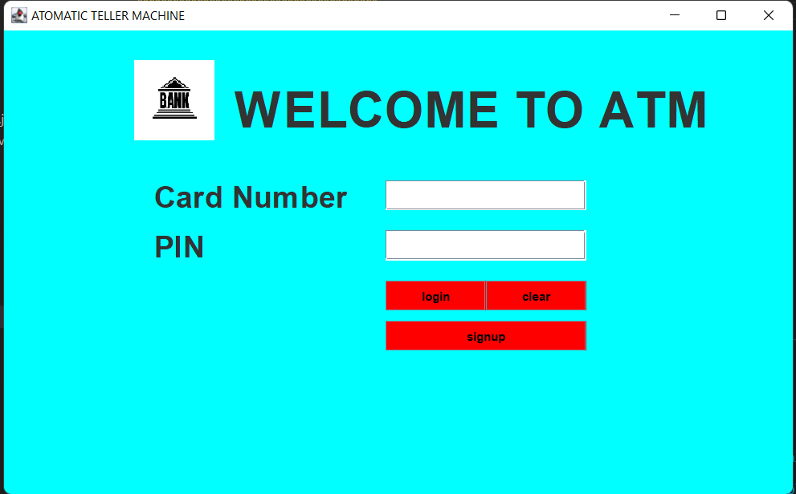

**SIGNUP_PAGE:**

aprogress bar is added to the form to get how much information is filled by the user. If any field is empty the user cannot move forward until the filed is filled.

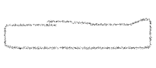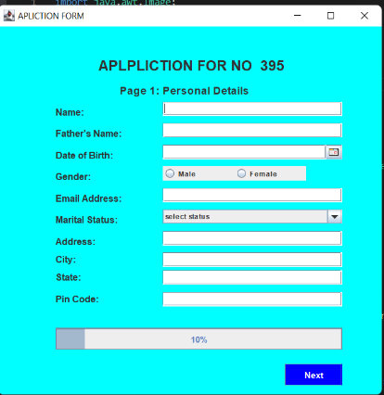 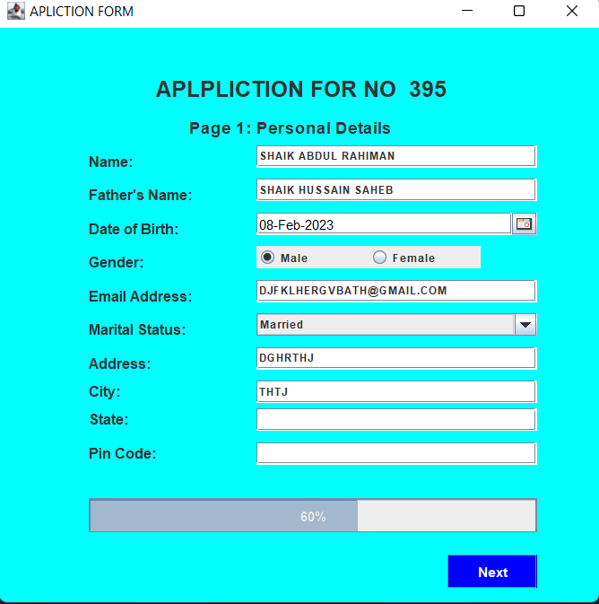 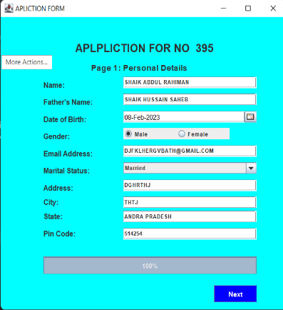** PAGE-1**

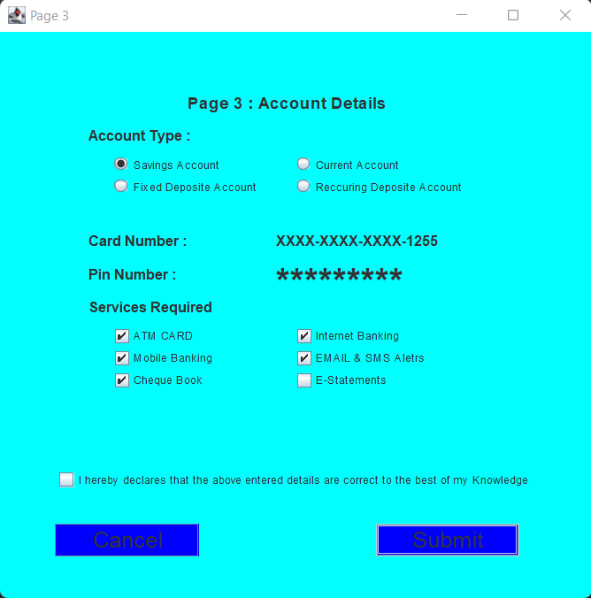 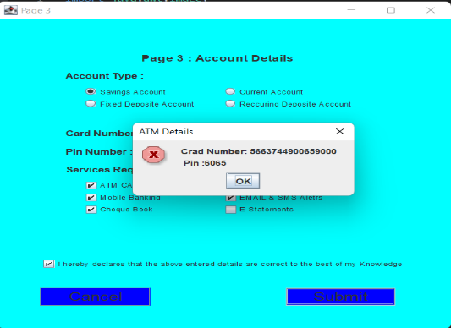

**ATM_PAGE:**

This is the main atm_ here user can do all hos functions mentioned in the project.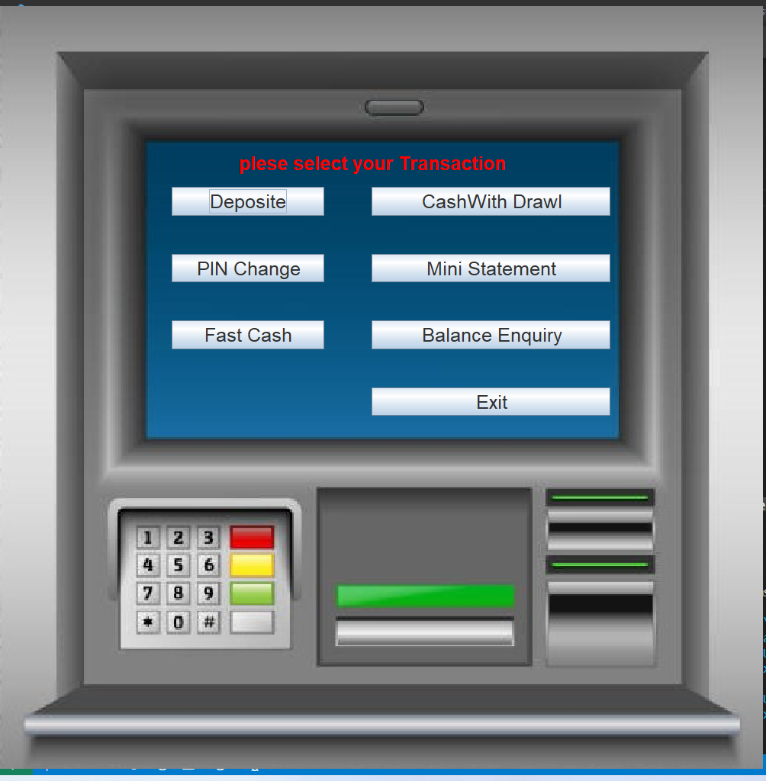

**MINI STATEMENT PAGE:**

This is the sample of mini_statement page get by the user.

